**IMPERIAL COLLEGE LONDON**

**BSc and MSci DEGREES – JANUARY 2014, for Internal Students of the Imperial College of Science, Technology and Medicine**

**This paper is also taken for the relevant examination for the Associateship**

**ADVANCED CHEMISTRY THEORY IIIA**

**Paper 1**

**Tuesday 14th January 2014, 14:00-16:15**

**PLEASE NOTE THAT IT IS DEPARTMENTAL POLICY THAT THESE EXAM QUESTIONS MAY REQUIRE UNDERSTANDING OF ANY PRIOR CORE COURSE.**

**USE A SEPARATE ANSWER BOOK FOR EACH QUESTION. WRITE YOUR CANDIDATE NUMBER ON EACH ANSWER BOOK.**

**Year 3/0114 Turn Over**

**3.I2 – Advanced Main Group Chemistry**

Answer part a) **AND** partb)and **EITHER** part c) **OR** d) of this question.

1. Answer **BOTH** parts of this question.
2. The estimated ΔHf for the hypothetical solid Xe+F- is large and positive. Discuss how this estimation can be made using a Born-Haber cycle. Which term is the dominant factor in the thermodynamic cycle? Would the analogous krypton fluoride KrF be more or less readily formed?

(10 marks)

1. Give a specific example of the use of XeF2 as a fluorinating reagent and give a reason why it is a convenient reagent to use for this type of transformation. (3 marks)
2. Give a synthesis for a structurally characterised compound containing a Bi=Bi double bond using BiCl3 as the bismuth starting material. What feature enables this compound to be isolated when this has not been achieved for most other Bi=Bi species? Draw the structure of the molecule chosen, illustrating the important features, and describe the bonding involving the Bi atoms.

(7 marks)

1. Give two different synthetic routes by which a silene can be made and illustrate each route with a specific example. What would the products be from the reaction of a silene with:
2. Itself
3. O2
4. Ethanol

(5 marks)

1. Using SeCl4 and a suitably substituted diazabutadiene derivative as two of the starting materials, show how a cyclic compound containing an Se2+ centre can be prepared. How is this soft cationic centre stabilised and which features of the compound suggest that it might be a useful Se2+ transfer agent?

(5 marks)

**3.O11 – Organic Synthesis Part 2**

Answer **ALL** parts of this question.

1. For **EACH** of the compounds **A** **AND** **B** shown below, show a simplifying C–C bond disconnection. Identify the synthons implied by your disconnections, and write down the synthetic equivalents of the synthons.

(2 x 5 marks)



1. Explain how compound **C** below may be disconnected using a palladium-catalysed cross-coupling reaction, identifying the reactants you would use in the forward reaction. Give a mechanism for your proposed transformation.

(5 marks)



1. Devise a synthesis of **EITHER** compound **E OR** compound **F** shown below. Show clearly your retrosynthetic analysis, identifying synthons and synthetic equivalents where necessary. Propose reagents for your forward synthesis.

(10 marks)



**3.P9 – Photochemistry**

Answer part a) and **EITHER** part b) **OR** part c) of this question.

1. Answer **ALL** parts of this question.
2. A porphyrin has a singlet excited state lifetime of 4 ns. The quantum yield of triplet formation is 25 %. What is the rate constant for intersystem crossing from the singlet excited state to the triplet state?

(2 marks)

1. Draw a Jablonski Diagram for a molecular chromophore, clearly illustrating on this diagram the processes of light absorption, internal vibration relaxation, intersystem crossing, internal conversion, fluorescence and phosphorescence.

Indicate on this diagram the S00 → S13 and T10 → S02 optical transitions.  
 (6 marks)

1. Explain, with reference to suitable potential energy surfaces, the process of photoisomerisation of asymmetric alkenes.

(4 marks)

1. Answer **ALL** parts of this question.
2. In the absence of any photochemistry, what factors determine the fluorescence quantum yield of a molecule in solution (i.e. why do some molecules show high fluorescence yields, and others very low fluorescence yields)?

(5 marks)

1. The quenching of molecular fluorescence can be used to monitor photochemical activity. Demonstrate that:



defining all terms used.

(4 marks)

QUESTION CONTINUED OVERLEAF

1. The fluorescence quantum yield of a molecular dye in solution was measured to be 0.3. Covalent attachment of a quencher to this dye resulted in a reduction of this fluorescence yield to 0.1.
2. Determine PC in the presence of the quencher.

(2 marks)

1. The singlet excited state lifetime of the isolated dye in solution was measured to be 5 ns. Determine the rate constant for photochemical quenching in the presence of the quencher.

(2 marks)

1. Answer **BOTH** parts of this question.
2. Photoinduced electron transfer was measured in a series of donor-acceptor molecular dyads:

1D* - A→ D+ - A-

The graph on the next page (page 5) shows a plot of the measured rate constant for electron transfer as a function of reaction free energy. Explain the physical origin of this behaviour.

(10 marks)

QUESTION CONTINUED OVERLEAF

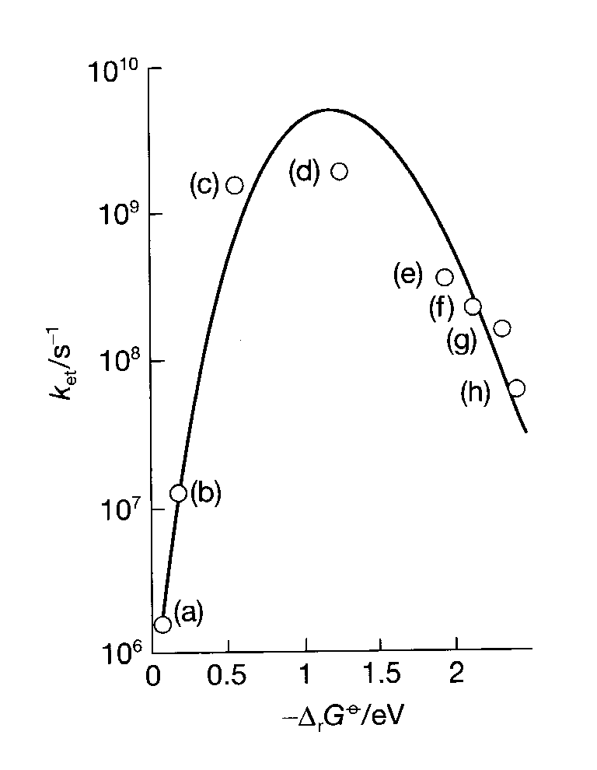

1. For the dyad corresponding to point (d) on the graph, what would you expect to be the temperature dependence of the electron transfer rate constant? Justify your answer.

(3 marks)